34.103: a) 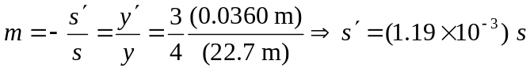
b) To just fill the frame, the magnification must be 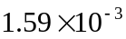 so:
